

Project Plan

OutSports

An application to facilitate the safe practice of sports in a group.

Software engineering 2020-2021

Erasmus Group:

Inês Santos 884840

Nuno Nogueira 884842

Rui Ramos 884843

Index

1 Introduction 3

1.1 Project Overview 3

1.2 Project Deliverables 3

1.3 Evolution of the Project 4

1.4 Reference Material 4

1.5 Definitions and Abbreviations 5

2 Organization of the Project 6

2.1 Process Model 6

2.2 Organizational structure 6

2.3 Organizational Interfaces 7

2.4 Project Responsibility 7

3 Description of management processes 8

3.1 Objectives and Priorities 8

3.2 Assumptions, Dependencies and Constraints 8

3.3 Risk Management 9

3.4 Monitoring and control mechanisms 10

3.5 Team planning 11

4 Description of technical processes 12

4.1 Methods, tools and techniques 12

4.2 Software documentation 12

4.3 Project support features 12

5 Work Planning 13

5.1 WBS (Work Breakdown Structure) 13

5.2 Workflow diagram 14

5.3 Grannt diagram 16

5.4 Needed Resources 18

5.5 Allocation of Budget and Resources 18

5.6 Planification 18

# Introduction

## Project Overview

Our project consists of an android app designed to help monitor and record the practice of outdoor sports recommended for running/walking with a group or alone, with features geared towards the achievement of that goal in a safe and efficient matter. We aim to provide these features by the end of the semester:

* Client local account that contains the data of all their activities. The saved data would correspond to the number of km made in a trail that can be viewed in a map and the average speed made by the client.
* Whenever the users want to perform a group activity, there are the features that allow them to make a “team” in this mode they can:
  + Know the location of all team members in real-time on a map.
  + Click on a user in their team and view information such their distance to the user.
  + Whenever someone is stopped for more than x minutes a notification will be sent to every team member (toggle function).
  + If someone from the team gets separated the last known coordinates will be sent to every person in the group (toggle function).

## Project Deliverables

List of the required documentation with related pre-established deadlines:

1. Project Proposal (01/10/2020)
2. Project Plan (18/10/2020)
3. Analysis and specification document (27/10/2020)
4. Testing plan (14/11/2020)
5. Design Document (9/12/2020)
6. Code and final delivery (15/01/2021)

## Evolution of the Project

The project will have various activities that will be carried out in parallel by the various group members to provide results faster.

It is our goal to use git and GitHub for version control and to have more than one person interact in the same project independently but also on the same section of code without interference.

That being said we predict five distinct phases for this project:

* Requirements analysis
* Application design
* Drafting of documentation
* Code development
* Application test

The project, in the future, may be subject to software revision to optimize and improve the service offered and simplify the user experience.

## Reference Material

As of the time writing this project plan the reference material has been:

* Slides of the Software Engineering course (2020/2021) (moodle)
* Official Android API documentation (<https://developer.android.com>)
* Instrucional Youtube vídeos
* geeksforgeeks.org

## Definitions and Abbreviations

**Software**: Software is a set of instructions that must be followed and executed by a mechanism, be it a computer or an electromechanical device. It is the generic term used to describe programs, apps, scripts, macros and instructions for directly embedded code.

**Java**: High-level object-oriented programming language.

**Github**: It's a website used by developers, who upload their source code programs and make it downloadable by users, it also provides hosting for software development and version control using Git.

**Git**: Git is a distributed version-control system for tracking changes in source code during software development.

**Gantt chart**: A Gantt chart is a project management tool assisting in the planning and scheduling of projects. Project management timelines and tasks are converted into a horizontal bar chart, showing start and end dates, as well as dependencies, scheduling and deadlines, including how much of the task is completed per stage and who is the task owner.

**Pert diagram**: A PERT chart is a project management tool that provides a graphical representation of a project's timeline. The Program Evaluation Review Technique (PERT) breaks down the individual tasks of a project for analysis.

**App**: Short for application, or software program intended for an end user. The term is usually used with reference to mobile terminals.

**API (Application Programming Interface)**: An API is a set of programming code that enables data transmission between one software product and another. Their usefulness is especially to reuse code already implemented by the company that created the platform itself.

**Android**: operating system developed by Google that allows operation applications on mobile devices.

# Organization of the Project

## Process Model

The process model that we choose is the Agile Model (Extreme Programming).

In our opinion, this is the model that adjusts better to our project because we are a small team, which force us to keep on high alert throughout the development to prevent having any problems in the future.

Also, we need to develop efficient strategies to facilitate the development and combination of ideas.

Our main focus is to develop a quality project in order to ensure client satisfaction.

One of our main concerns is to start the project immediately in order to decide which resources to implement throughout the project. We plan to have daily virtual meetings to access the work progress and discuss individuals concerns or doubts.

We hope that this work model gives us a better use of the frame time we have available.

## Organizational structure

The work team has 3 members with equal decision power. We decided not to have a permanent leader to prevent an abuse of power which could jeopardize the entire project.

All members work together in every step and decision which helps to have a bigger group union ensuring a continuous and spontaneous flow of ideas.

Nuno was the primary code developer while the documents and research was done primarily by Inês and Rui.

## Organizational Interfaces

Due to the current pandemic, it´s not possible to have face to face meetings nowadays so we will have to use the digital platforms that give us the opportunity to interact with each other regularly.

To communicate throughout the development of the project we created a room on Discord and a chat on Messenger that allow us to organize meetings and to discuss details that pop up during the work.

For all the members of the group having real-time access to the work papers and other resources for the development of the project, we will use Google Drive. For better management of software development, we will use the GitHub platform.

## Project Responsibility

As discussed earlier we will not have a project leader. All tasks are going to be shared by the workgroup members to limit the errors and facilitate project development.

In general, the code was made mostly by Nuno and research and document development were made by Rui and Inês.

# Description of management processes

## Objectives and Priorities

Our objective is to create an app that takes advantage of peer-to-peer communication as well as smartphone sensors.

Our priorities are to meet all the pre-established deadlines while respecting the specifications of the client, having a functional app and all the supporting documents written accordingly to the standards and having a good work environment between the members of the group and the professors.

## Assumptions, Dependencies and Constraints

**Assumptions**:

* The smartphone has a working touch screen.
* The smartphone has a GPS sensor, an accelerometer, and an altitude sensor completely functional.
* All the members have the knowledge to develop the app or the skills to learn how to.
* The android version of the smartphone is compatible with the app.

**Dependencies**:

* Use Java as the programming language of the project.
* The time required to learn about the Android Studio environment and well as additional libraries we might use.

**Constraints**:

* Be able to delivery everything asked for each deadline.
* Have multiple subjects and therefore have multiples exams and projects.

## Risk Management

|  |  |  |  |  |
| --- | --- | --- | --- | --- |
| # | **Risk** | **Category** | **Probability [1 to 5]** | **Impact [1 to 5]** |
| 1 | A member of the team have a health problem | Human Resources | 3 | 5 |
| 2 | A member of the team leaves the group | Human Resources | 1 | 5 |
| 3 | Needing more time to learn how to develop the app than what as initially estimated | Project | 2 | 3 |
| 4 | Computer failure | Project | 1 | 4 |
| 5 | Don´t have  all the work done before the deadline | Project | 2 | 2 |
| 6 | Have other projects and exams from other subjects | Human Resources | 4 | 3 |
| 7 | The group can´t work well together | Human Resources | 1 | 3 |
| 8 | Have bugs on the app | Product | 2 | 4 |

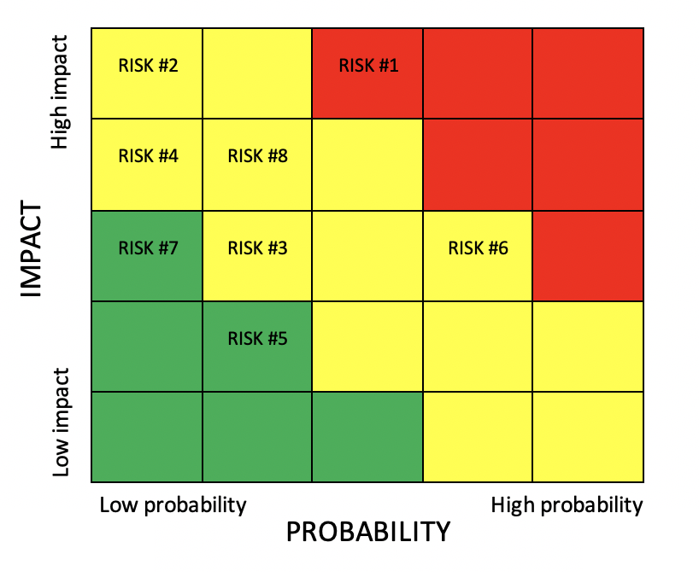

## Monitoring and control mechanisms

Throughout the project, we will be in constant contact by using a Discord room created to this purpose and well as a chat on Facebook Messenger.

The members of the group will have multiple reunions to discuss all the decisions needed to take as well as to check each other work to ensure we delivery everything as decided previously and to help if we have difficulties in any part of the work.

## Team planning

**Knowledge to develop the Android application:**

* To develop the app, as none of the members of the project has experience in developing Android applications, we will start by learning the basic concepts about the development and doing that will take us some time. To reduce the learning time as much as possible we will follow every lesson about Android development and help each other at the beginning as well as throughout the project.

**Knowledge of Java programming language:**

* It is necessary to know how to code in Java, something that every member has a little bit of experience as we have done at least one project in Java.

**Knowledge of all the documents needed to support the project:**

* To write the support documents in a correct way we will follow every indication and tips given by professor Tino Cortesi.

**Use of GitHub platform:**

* Understand how the platform works, especially how to upload the source code and how to keep every version organized to simplify the code exchanges within the group.

# Description of technical processes

## Methods, tools and techniques

We plan on being in constant communication during the development of this project and sharing acquired knowledge with each other in order to make a well-developed end product. During the development, we will perform tests and discuss the findings and ways to improve the application.

The tools we are using are the following:

* Android studio for writing and developing the app;
* Google Drive for storage and sharing documents;
* Google Docs for the development of reports and other necessary documents;
* Discord and Facebook messaging for fast and real-time communication;
* An emulator for testing our application;
* Github as a hosting service for cooperative code development;

## Software documentation

The documentation will be provided in the dates already defined in point 1.2, these documents will be delivered in the Moodle platform in order to be evaluated. There is the possibility for documents in question to be altered if during the development of the application the group finds it justifiable and necessary.

## Project support features

In order to keep our project supported during development we intend to consult online guides and tutorials, class powerpoints as well as class recordings provided by the teachers in the platform Panopto.

In addition to this, we will adhere to deadlines and keep up-to-date documentation and finally use versioning in order to backtrack to a previous version if we find unwanted behaviour from the current version.

# Work Planning

## WBS (Work Breakdown Structure)

1. Realization of the necessary initial documentation
   1. Project communication for approval
      1. Specification of main features
      2. Specification of required sensors
      3. Specification of how communication between devices will be done
   2. Project plan
      1. Introduction
      2. Organization of the Project
      3. Description of management processes
      4. Description of technical processes
      5. Work Planning
   3. Analysis and specification document
      1. Requirements analysis
      2. Data Analysis
      3. Design analysis
2. Application development
   1. Distribution of features by group members
   2. Code development
      1. Base code development
      2. Graphic front development
   3. Server integration
   4. Documentation
3. Tests
   1. Test plan
   2. Preliminary tests
      1. Testing according to the test plan
      2. Fix bugs found
      3. Documentation of the results obtained
   3. Beta version
      1. Analysis of the features implemented
      2. Code correction and optimization
   4. Alpha version
      1. Analysis of the features implemented
      2. Code correction and optimization
4. Product documentation
   1. Product description
   2. Description of the usable functions
   3. User manual and commands
5. Project delivery for evaluation

## Workflow diagram

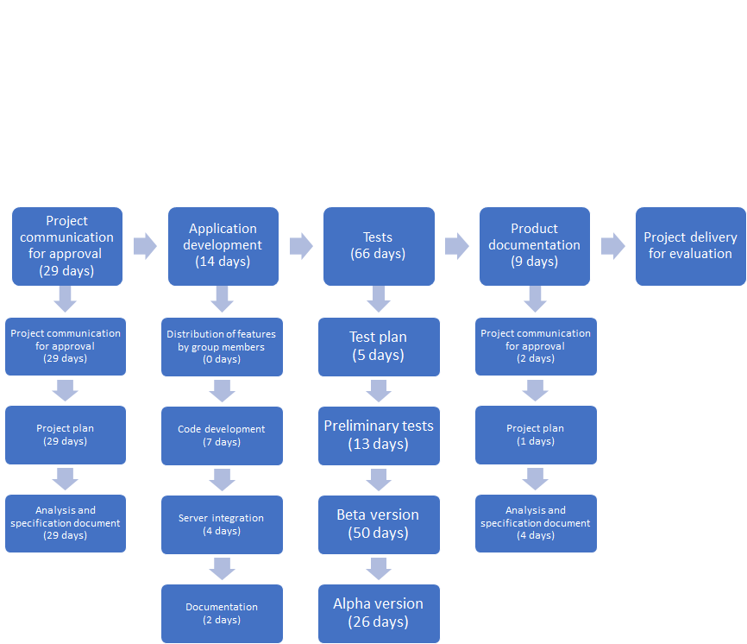

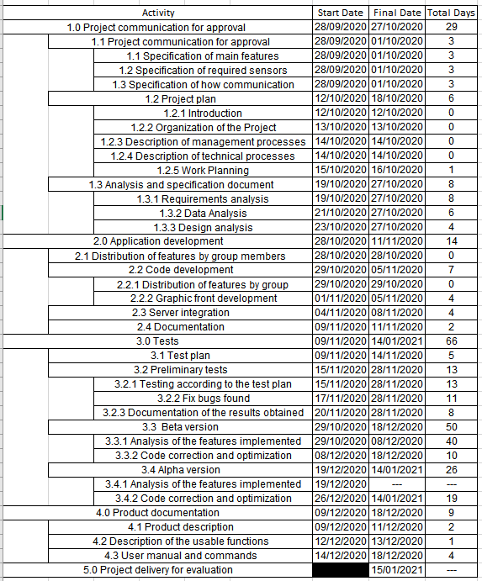

## Grannt diagram

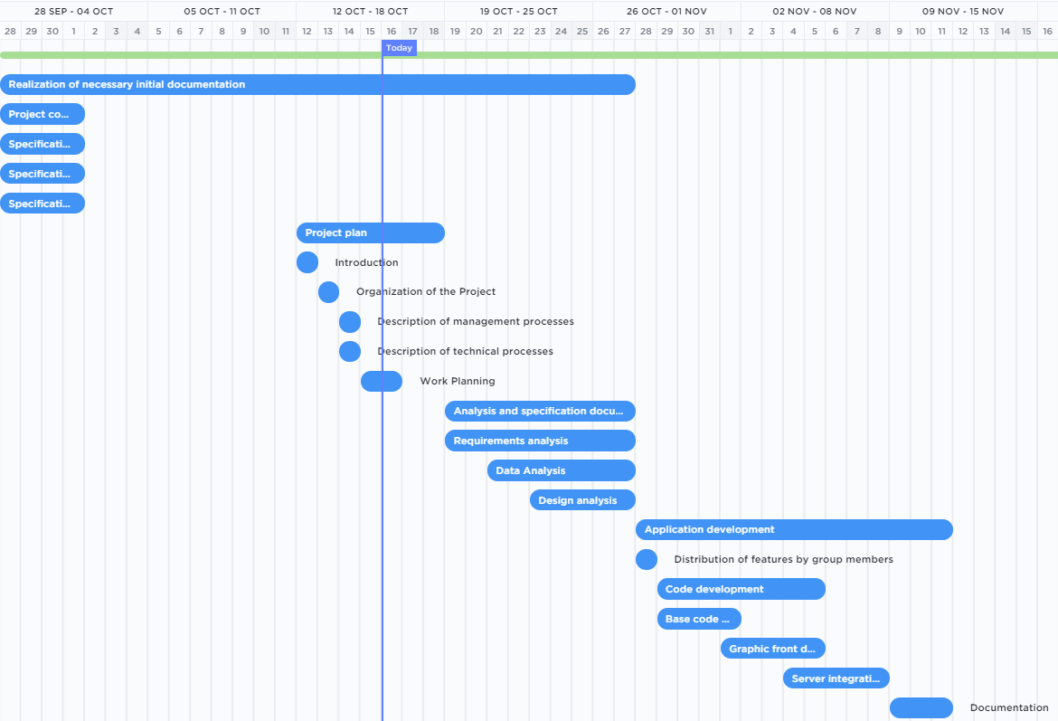

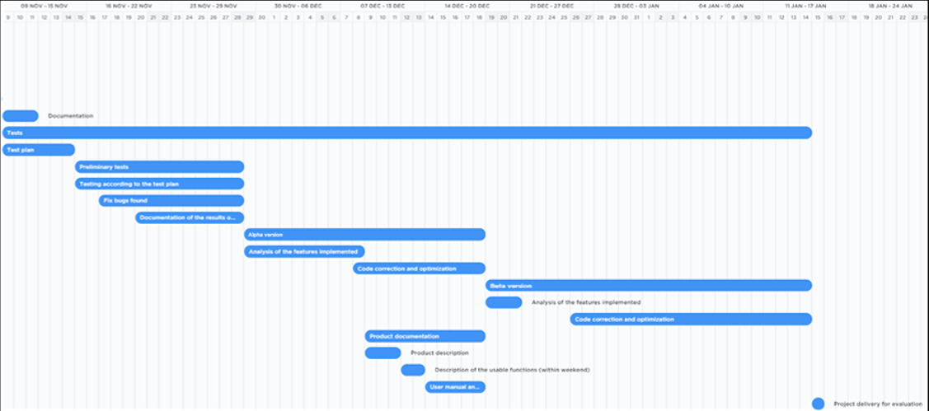

## Needed Resources

The resources need for the project:

* **Human Resources**: The three members of the project;
* **Hardware**: Every team member will use their own computer;
* **Software**: We will need Discord to communicate between the members, the Android Studio to do the development of the app and GitHub to control the different versions of the app.

## Allocation of Budget and Resources

As this is an academic project the only cost is the time each member will dedicate to the project. We won’t have a cost associated with software because it’s all free. As far as the hardware we will use our own computers that are already bought so it’s also “free” to use them to do everything that needs to be done.

## Planification

The project planning is based on deadlines defined during the Software Engineering course, which are established as follows:

* Definition of working groups - 4/5 students (by 9/21/2020)
* Initial proposal (9/29/2020)
* Project Plan (10/13/2020)
* Analysis and specification document (10/27/2019)
* Testing plan (11/14/2019)
* Design Document (09/12/2019)
* Code and system online (01/15/2021)

In addition, deadlines have been included for us as a group, which will allow and determine the fulfilment of requirements in time for the main deadlines, as well as giving us an overview of the objectives achieved and/or the problems that arise.